Cloud Junction – Riverside – Sales Force – Seradex DBOX API Link

Document Summary
This document will provide a quick overview on how to login to the DBOX API and provide a list of requests you can use to fulfil the requirements outlined by Riverside.
These requirements were:
- Create a Prospect
- Load Prospect/Customer Information
- Load Estimate/Sales Order/Invoice/Credit Note Information
If there is anything you find lacking or don’t understand, let us know.

API Information
I will be attaching a Postman JSON collection to the email alongside this document. This can be used to import all of the API definitions into Postman, which is an application developed by Google that allows you to send and manage API requests. In said collection JSON you will see definitions of all the API routes you should need.

How to Authenticate with the API
Riverside has created an email address that can be used for this API Integration. I have set it up to have access to DBOX.
Username: api.integration@riversidemillwork.ca
Password: Cl0uDjUnc!1on
You can pass that information to the Token call in the JSON collection, and it will allow you to login and provde you with an access_token.
The Postman Collection has a {{baseUrl}} variable set, which corresponds to https://riverside.dboxnow.com/api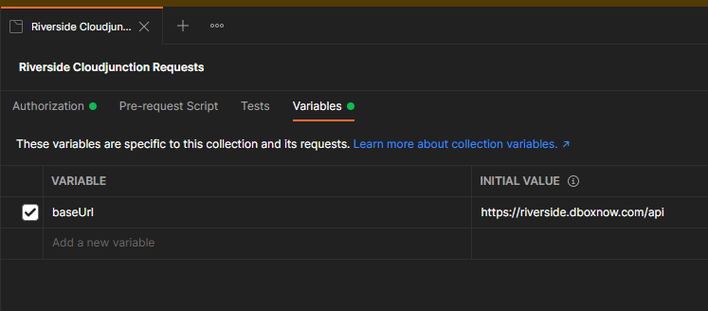

Once you have an account, to use the API requests, the first thing you will need to do is send the Token request in the collection.
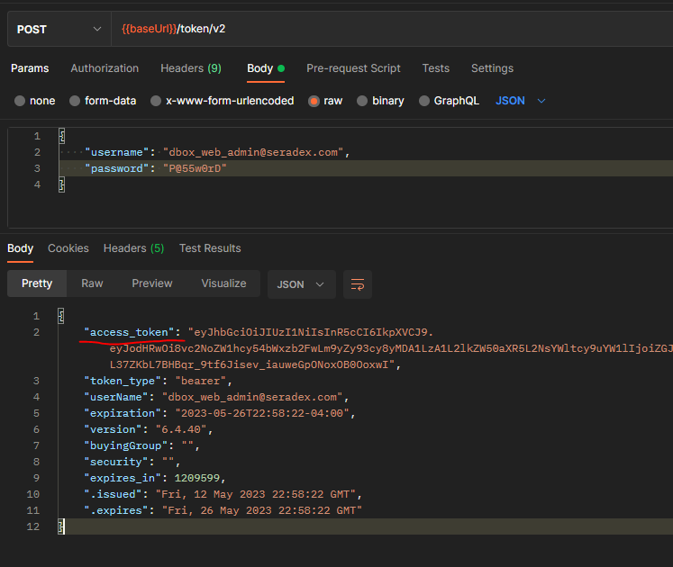
You will then need to take the access_token value, and use it in the Authorization Header as a Bearer token in every other request.
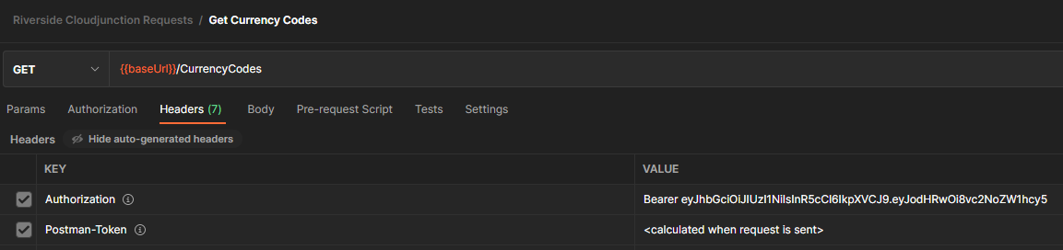
In Postman, for testing purposes you can copy the access_token into the main Authorization window of the collection and it will automatically apply it to any calls in the collection.
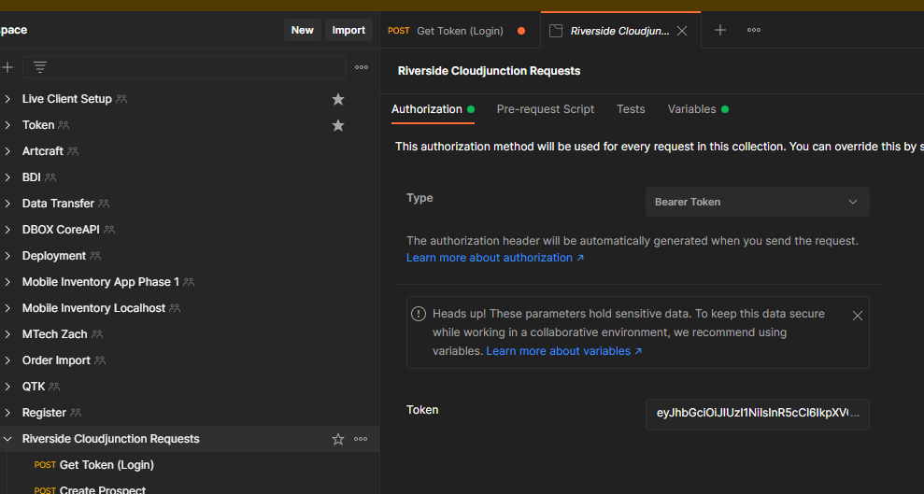

Creating a Prospect
This is probably the only part of your request that has some stipulations. There are certain required fields for creating a Prospect (I have listed them as a comment in the example JSON)
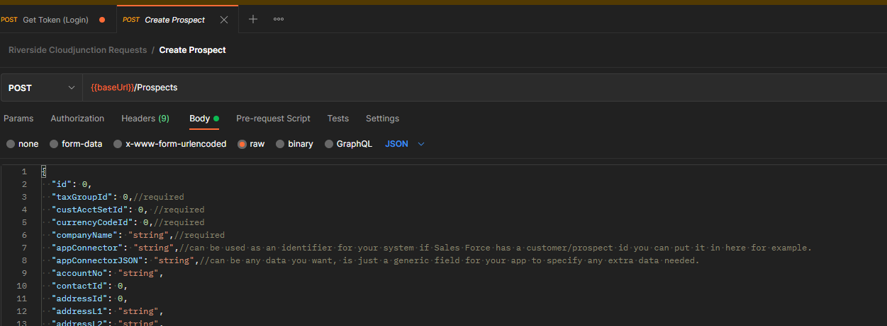
Every other ID can be left as null when creating the prospect, but the TaxGroupId, CustAcctSetId and CurrencyCodeId are required. I have provided API calls to get all the SalesTaxGroups and CurrencyCodes. Customer Account Sets are filtered by the Currency Code.
If we aren’t sure which Tax Groups/Currency Codes to use, Riverside could potentially fix this manually later when they go to convert the prospect to a customer and you could just use the first tax group/currency code/cust acct set, but this may need discussion with Riverside.

Search/Getting Transaction Information
The simplest way for us to get you the Estimate/Sales Order/Invoice/Credit Note data is to use our Search feature. I have supplied API calls to use our “core” searches to retrieved data. If necessary we can customize the query in the back end to return less/more data and use a custom search instead of a core search.
The Search API has the ability to filter on any field in the search, the Get Estimate Search POST request in the collection has an “appliedFilter” in the JSON Example. Basically, you would want to get the results for the search using the GET, then apply any filters using the response of that search and sending it back using the POST to filter the data and return more results.
My example will return all estimates where the Estimate No contains “Q200”
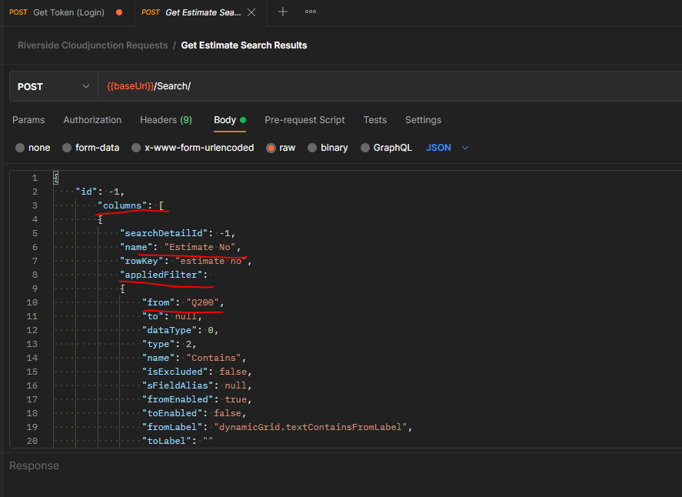
Hopefully this is enough information to get you started, and that the Postman Collection can provide you with enough information to test and figure out the system. If there are any questions or you need further clarification feel free to reach out.

